Important Notes:
- Do not code only on the main function, code every module on its own separate function
- You are only allowed using Merge Sort Algorithm
- You are allowed using a struct to store all your variable that needed

Sotte Mart
Sotte Mart is a branch of a very big, well-known market. Despite being a smaller entity, this little market has big ambitions and doesn't want to be outdone by its larger counterpart. Determined to rise above the competition, Sotte Mart is eager to implement a superior system that will set it apart and make it the best mart in the area. In their search for the perfect solution, they discovered a highly skilled C Programming Language programmer—and that programmer is you. Now, you are tasked with creating a system menu that will help Sotte Mart achieve its goal of becoming the best mart there is.
- In the first time, the program will read the file which the name is ‘data.txt’ using the following format:
Code#Name#Type#Price#Quantity
- If the file does not exist, do not insert any data.
- If the file exists, but there are no content inside it, do not insert any data.
- If the file exists and there are contents inside the file, insert the data and store it in an array.
- The program consists of 4 menus:
- Add Item
- View Item
- Buy Item
- Exit
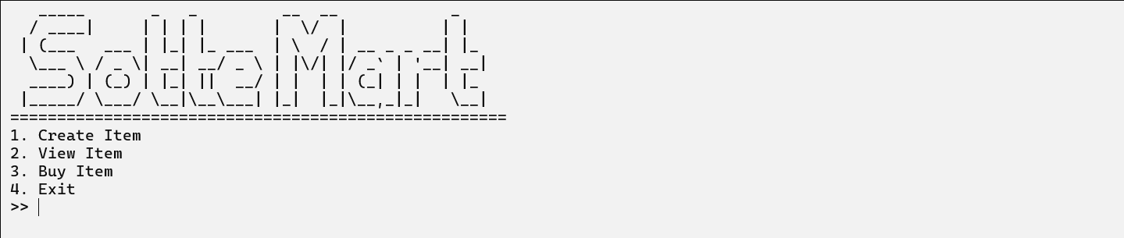 Figure 1. Main Menu

- The program will ask the user to input the menu number, which must be between 1 and 4
- If the user chooses menu 1 (‘Add Item’), then:
- The program will ask the user to input Item details, which consists of:
- Item Name, validate that item name length must be between 10 – 15 characters (inclusive).
- Item Type, which must be between Grocery, Electronic and Clothing (case sensitive).
- Item Quantity, which must be at least 50 and not more than 1500.
- Item Price, which must be more than 100.
- If the inputs are valid, generate Item Code using following formula:
Format: AAABBB
A First 3 Capitalized Characters of the Item Name
B random number between 0 and 9
Example:
Item Name: Juice Blender
AAA | JUI
Random Number 1 | 8
Random Number 2 | 5
Random Number 3 | 3
Item Code: JUI853
- If item is successfully created then display a success message and add the data to an array.
- Then display a message ‘Press enter to continue…’

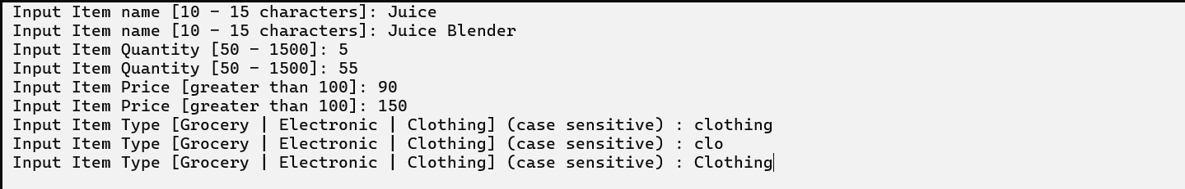Figure 2. Create Item Menu Details
Figure 3. Success Message
- If the user chooses menu 2 (‘View Item’), then:
- The program will ask the user to choose between the types of Items (grocery, electronic, clothing and all) and it is case insensitive.
- If the user chooses a menu between the types, then show the item list according to the selected item type. Show All Items as Is When "All" is Chosen.
- The user can exit anytime by inputting 0.
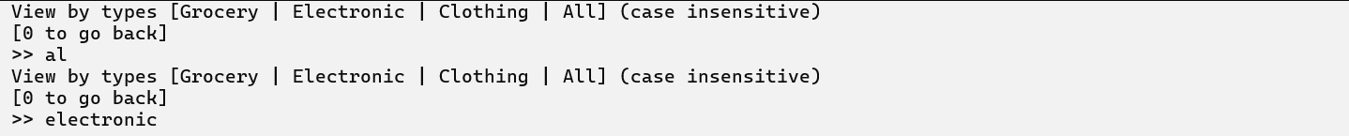 Figure 4. View Item Menu
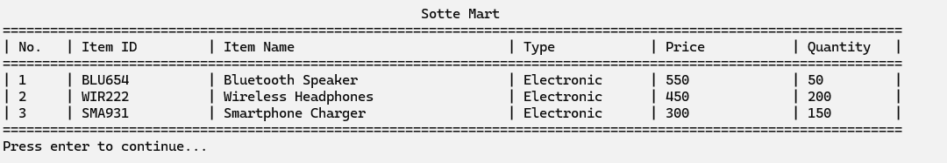 Figure 5. View Item Result
- If the user chooses menu 3 (‘Buy Item’), then:
- The program will ask the user to choose between the types of Items (grocery, electronic, clothing and all) and it is case insensitive, and user can go back to the main menu by inputting 0.
- If the user chooses a menu between the types, then show the item list according to the selected item type. Show All Items as Is When "All" is Chosen.
(Refer to Figure 4 to see the example).
- Then the program will ask the user to input the Item ID the user wants to buy. (case sensitive)
- After entering the ID, the user will be prompted to input the desired purchase quantity. Ensure that the entered quantity does not exceed the available stock and is not equal or less than 0.
- Display the final bill showing the total cost of the purchased items.
- Include a random chance (20% occurrence) to apply a discount of 10% to the total cost.
- Total cost without the discount:

Quantity * Price

- Total cost with the discount:

Quantity * Price – (Quantity * Price * 10%)

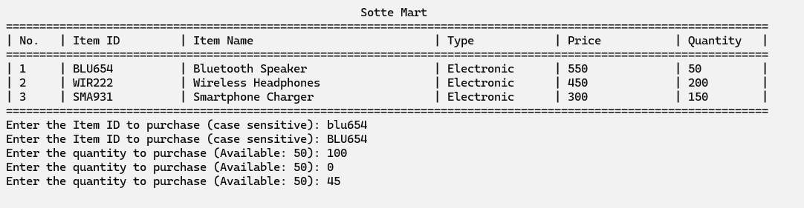
Figure 6. Buy Item example

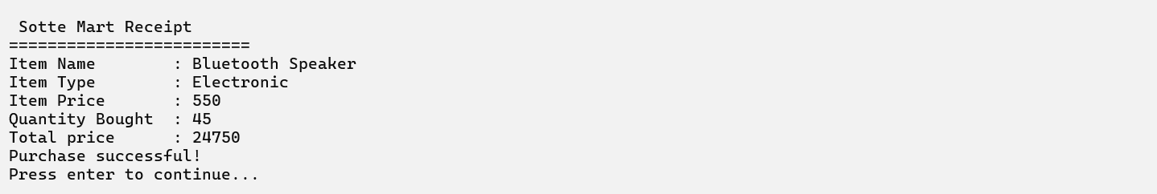
Figure 7. No Discount Example

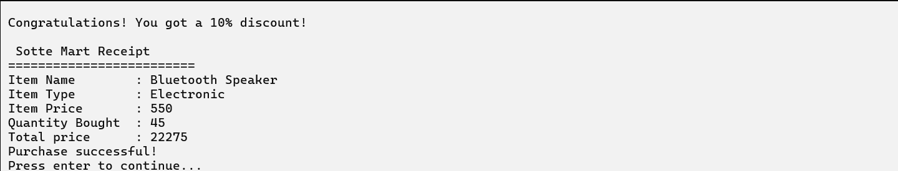
Figure 8. Discount Example

- If the user chooses menu 4 (‘Exit’), then:
- The program will save the menu list to the file which the name is ‘data.txt’ in descending order by price using the following format:
Code#Name#Type#Price#Quantity
- After that, the program will be closed.
Run the program for more details!

